Thrilling Regattas for Everyone: Sailing Aboard Vanderbilt's Historic 12mR VIM at the Voiles de Saint-Tropez

Noblesse®, leading the way in unique yachting experiences, is set to join the Voiles de Saint-Tropez with the famed classic yacht VIM.
Initially commissioned in 1939 by yachting icon Harold S. Vanderbilt, VIM represents a remarkable chapter in yachting history. Noblesse now offers sailing enthusiasts the opportunity to participate in thrilling competitions aboard VIM, either for the entire week or for individual days.

The Voiles de Saint-Tropez are scheduled from September 28th to October 6th, 2024. Established in 1999 by the Société Nautique de Saint-Tropez, this event gathers an impressive array of classic boats, some over a hundred years old, as well as cutting-edge modern yachts. With over 250 participating vessels, this exceptional blend celebrates the original spirit of fair play: "the best regattas on the water and the best atmosphere on land.

"The participation of VIM at the Voiles de Saint-Tropez is a tribute to the rich history of these elegant yachts and our deep passion for this sport. Our premium regatta package offers guests the opportunity to sail aboard VIM during the regatta—a unique experience unparalleled before," says Adi Konstatzky, founder and CEO of Noblesse.

About VIM: Harold S. Vanderbilt commissioned VIM, a classic 12-metre class yacht, in 1939. Renowned designer Olin J. Stephens of Sparkman & Stephens was tasked with her design. Vanderbilt envisioned a yacht capable of winning the America's Cup. While narrowly missing this goal in 1958, VIM nonetheless secured a lasting place in sailing history. Since then, she has remained actively in service, sailing in some of the most prestigious regattas in the Mediterranean today.

For more information, please visit https://noblesse.yachts/regattas/voiles-de-saint-tropez/ or contact info@noblesse.yachts

About Noblesse®
Noblesse Yachts & Events represents exclusive yachting experiences that uniquely blend history, culture, lifestyle, and sport. The company is committed to crafting exceptional maritime events.

Noblesse Yachts' media contact is available in English, Dutch, and German:

Melanie Engel
Office Netherlands
Creative Director
P: +41 78 226 17 10 (also WhatsApp)
P: +31 6 83 97 21 90 (also WhatsApp)
M: melanie@noblesse.yachts

PREVIEW IMAGE // For high-resolution images, please click on the preview image. These images are free to use in connection with the press release and the indication of the authorship.
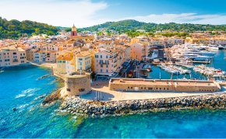 | Saint Tropez  Dimensions: 5464x3640px  Size: 12.1mb  Resolution: 300dpi  © Depositphotos
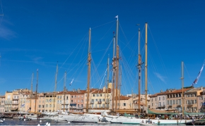 | Port of Saint-Tropez  Dimensions: 6567x4378px  Size: 14.8mb  Resolution: 300dpi  © Depositphotos
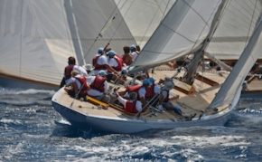 | Yacht VIM  Dimensions: 4200x2800px  Size: 5.70mb  Resolution: 300dpi  © Nico Krauss
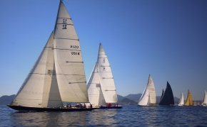 | 12mR Class @ RR Cannes 2023  Dimensions: 5634x3753px  Size: 12.9mb  Resolution: 300dpi  © Noblesse
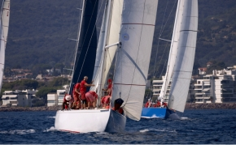 | Yacht VIM @ RR Cannes 2023  Dimensions: 6240x4160px  Size: 17.6mb  Resolution: 300dpi  © Noblesse
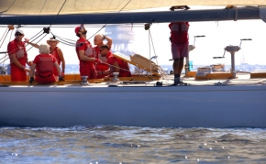 | Yacht VIM @ RR Cannes 2023  Dimensions: 6240x4160px  Size: 15.8mb  Resolution: 300dpi  © Noblesse
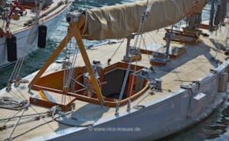 | Yacht VIM  Dimensions: 4200x2800px  Size: 5.28mb  Resolution: 300dpi  © Nico Krauss
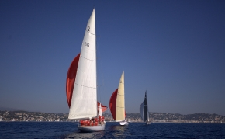 | Yacht VIM @ RR Cannes 2023  Dimensions: 5330x3550px  Size: 11.50mb  Resolution: 300dpi  © Noblesse
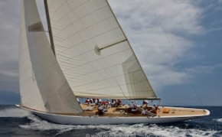 | Yacht VIM  Dimensions: 4200x2800px  Size: 5.70mb  Resolution: 300dpi  © Nico Krauss
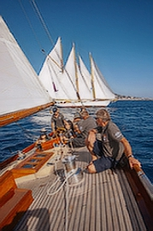 | Regates Royales Cannes 2023  Dimensions: 3289x4933px  Size: 9.06mb  Resolution: 300dpi  © Noblesse
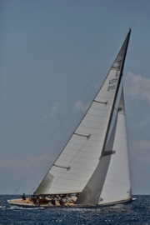 | Yacht VIM  Abmessungen: 3059x4200px  Größe: 3.89mb  Auflösung: 300dpi  © Nico Krauss
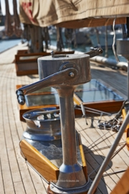 | Yacht VIM  Abmessungen: 2800x4200px  Größe: 4.08mb  Auflösung: 300dpi  © Nico Krauss

